**COS30002**

**Lab Report – Task 2 (7/3/2021)**

Ryan Chessum 102564760

* Designed a FSM
* Drew a Diagram for FSM
* Implemented a version of the FSM in python
* Updated the readme to include my name and what the repository was for

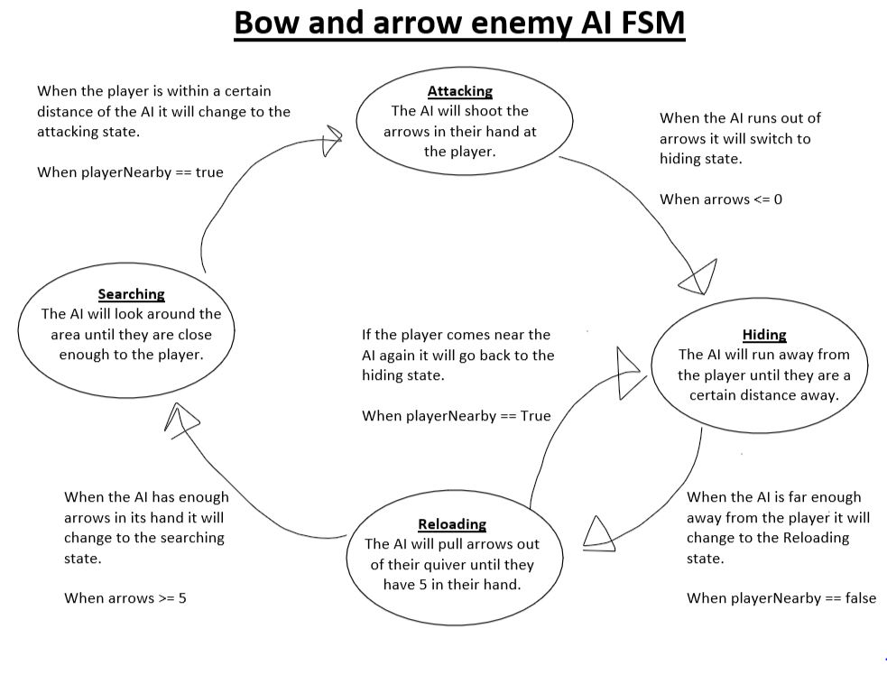

Finite state machine

My idea for an AI is an enemy with a bow and arrow. When the player is nearby, they will attack the player until they are out of arrows in their hand. After they run out, they will start to hide from the player and once they are hiding, they will pull more out of their quiver. Once they have more arrows, they will look for the player again and repeat.

States: Attacking, Hiding, Reloading, Searching

Variables: Arrows (Integer), playerNearby (Boolean)

Code:

# Bow and Arrow enemy FSM code - Ryan Chessum 102564760

import random

# variables

arrows = 5

player_nearby = False

states = ['attacking','hiding','reloading','searching']

current_state = 'searching'

running = True

max_limit = 100

game_time = 0

while running:

    game_time += 1

    # Searching: search for a player to shoot at

    if current_state is 'searching':

        # Do things for this state

        print("Searching...")

        rn = random.randint(0, 1)

        if rn == 0:

            player_nearby = False

        if rn == 1:

            player_nearby = True

        # Check for change state

        if player_nearby == True:

            current_state = 'attacking'

    # Attacking: Shoots arrows at the player

    elif current_state is 'attacking':

        # Do things for this state

        print("FIRE!!!!!")

        arrows -= 1

        # Check for change state

        if arrows <= 0:

            current_state = 'hiding'

    # Hiding: Runs away until the player is no longer nearby

    elif current_state is 'hiding':

        # Do things for this state

        print("RUN AWAY!!")

        rn = random.randint(0, 1)

        if rn == 0:

            player_nearby = False

        if rn == 1:

            player_nearby = True

        # Check for change state

        if player_nearby == False:

            current_state = 'reloading'

    # Reloading: reloads arrows into hand unless the player comes near

    elif current_state is 'reloading':

        # Do things for this state

        print("Reloading...")

        arrows += 1

        rn = random.randint(0, 1)

        if rn == 0:

            player_nearby = False

        if rn == 1:

            player_nearby = True

        # Check for change state

        if arrows >= 5:

            current_state = 'searching'

        elif player_nearby == True:

            current_state = 'hiding'

    # check for broken ... :(

    else:

        print("AH! BROKEN .... how did you get here?")

    # Check for end of game time

    if game_time > max_limit:

        running = False

print('-- The End --')